Breunna Bingham

CS-250 Software Development Lifecycle

Southern New Hampshire University

December 2, 2021

7-1 Final Project Submission

As a Scrum Master, I feel it is important to have a clear and concise Sprint Review and Retrospective. The first thing I want to discuss how the various roles on the Scrum-agile Team contributed to the success of the SNHU Travel Project. We had Christy who was out Product Owner. She provided outstanding direction to the team on the overall project. She appropriately assigned priority to tasks, which ultimately lead to our phenomenal burn-down chart, because we were able to be so efficient. Christy also kept the client in close communication and updated the client anytime we had questions or needed clarification on something. If the Client wanted to change anything, Christy was sure to get examples from the Client, and relay those thoughts and ideas to us seamlessly. This allowed us to make the client happy with the final product by making changes they felt the project needed as we progressed.

The next role I will talk about is mine, Scrum Master. I have gotten lots of feedback from you all and it looks like all the feedback was mostly positive. We were able to hold 15-minute meetings for our daily scrum every morning with only a few people arriving late. That is where I will agree that we can improve. As I have stated before it is imperative that we all arrive on time and are ready to present to our team our three questions: What did I do? What will I do? And what impediments did I have along the way. I was able to prevent these meetings from running over 15 minutes which helped us to remain efficient and focused on the tasks at hand. I also worked closely with Christy, our Product Owner and was able to organize with her, the user stories, knowing our team’s potential in finishing each of the tasks. Communication was phenomenal between everyone.

The next role I will talk about is my Testers and Developers, Brian, and Nicole. You both worked so well together and as a team. Your communication between one another was clear and you excelled in keeping up with the work that needed done. You showed up for the Scrum meetings and were prepared the entire project. If you had questions, you spoke up. While I know that you both were hesitant on the changes made halfway through the project requested by the client, you both embraced this change and made it happen. Brian, you corrected what you needed to appropriately welcome the changes to the development of the program and its testing steps. You were both efficient and accurate allowing us to move forward in a constant velocity. At daily scrums you addressed specific bugs and suggested priorities on which bugs need to be fixed first. Your reproduction logs were all very detailed and in a step-by-step format. This helped the developers understand the bug and where it needed fixed more clearly. Well done!

The Scrum-agile approach to the SDLC really helped each of the user stories come to completion. When Christy and I went over the user stories, we made several changes that was requested by the client throughout the project. Having and agile approach really allowed us to be flexible and welcome changes as they come. For example, the client wanted us to change the project from top destinations to something more specific, the top wellness destinations. This meant we had to change around the user stories to allow for this. This also meant that our Tester Brian was required to make very important changes to his testing approach as well. Everyone did a great job at embracing these changes to the user stories.

The Scrum-agile approach we decided to take has really helped us nail this project in it’s entirely. We had the client meet with Christy and request changes, that none of us saw coming, but our agile approach allowed for it. We all collaborated on what specific changes needed to take place and a timeline of when it was to take place, without evermoving the project deadline for completion. You all hit those timelines perfectly, and an agile approach allowed us to keep the same deadline without missing a beat in productivity. Christy reported back to the client that the changes that they requested had been approved and made, and they were very pleased with our flexibility and commitment to the project. Had this been a waterfall approach we may not have been able to implement and embrace the clients’ requests for changes, and we may not have even finished on time. By allowing us to test concurrently with development and make changes as they present themselves, we were more efficient and successful then we have ever been before on any other project. In addition to that, our client was so pleased, they plan to use our expertise and knowledge for any other developments they need in the future.

I’m very impressed, with everyone’s communication. Whether it was in person collaborating at scrum when an impediment was experienced or through emails, you were all very clear in your questioning and elaborated on what exactly you needed in return. Had we all not used effective communication, we would have used up so much valuable time guessing when trying to answer a team members question because they were not detailed enough in their expectations of a response, or in their questioning. A perfect example of excellent communication was this email: 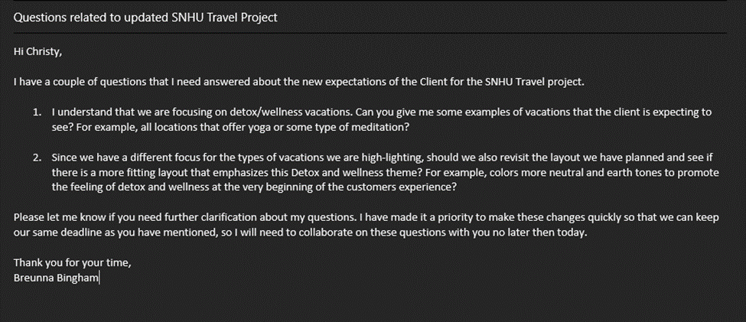 This email is a perfect example of clear and well thought out email that made communication between team members easy. This person asked questions and then provided suggestions to their questions so that the recipient knew the direction of the question and had an idea of what type of response the sender was looking for. The sender was very specific and detailed in noting when they would need an answer by so that it would allow them to continue moving at the same velocity as before. This allowed the team to collaborate among different ideas throughout the project.

In addition to the use of effective communication through email, we also implemented Azure Boards to use during our project. This increased collaboration across the team as well as maintaining efficiency. One main example of how Azure Boards helped was the ability to prioritize bug fixes. This allowed our Developers to see which bugs needed fixed first so that we wouldn’t be waiting for bug to be fixed in the future which would have slowed or even halted production. With the use of prioritization of bug fixes, we never experienced a slow in our velocity since all bugs were fixed simultaneously as we developed more and more code. This was a fantastic tool that we used to encourage team collaboration and communication.

I also want to touch base on some of the organizational tools and Scrum-agile principals that we used that really helped us be successful in this project. First and foremost, our online Radiator system, Azure Boards was amazing at keeping us up to date on tasks being performed by other team members and allowing us to see real time our progress in each Sprint. This tool also allowed our Client, Amanda to check in on the progress of the project, making the time spent between her and our Product Owner, Christy more valuable. Christy did not have to take so much time and meet with the client so frequently, because we utilized this tool. From a client’s perspective, they highly approved of this type of tool implementation. They stated that they wanted to be very involved in the development of the project and this allowed them to see changes made and user stories being completed in real time. This allowed them to feel closer to the project overall. When we would meet for our Daily Scrum meeting, we all constantly understood what each other was working on and could collaborate more effectively by understanding each other’s tasks in real time on Azure Boards. This also allowed us to have a constant flow of tasks needed to be completed to finish out the sprint. By using Azure Boards, we were able to share real time changes to the number of user stories left in the Sprint across the web, instead of just our white board in the conference room.

The overall effectiveness of the Scrum-agile approach for the SNHU project was positive. Some pros would be that we completed the project on time despite critical changes made along the way. We were not delayed by these changes and the agile approach allowed for it. Another Pro is I feel like we have collaborated and acted more as a team then individual players when we had a waterfall approach. Another Pro of an agile approach would be that the whole team learned and fixed things as they went. This gives our team experience in their own potential abilities and realize the potential in our teammate’s abilities. No longer is one person a specialist in only certain aspects of development. All work is done collectively and equally. Some cons to the agile approach are the transition to becoming immediately more flexible and adaptable to change. This did not come easy for a team that is used to a waterfall approach, but you all did an amazing job at adjusting. Another con is that the work presented seems a bit more complicated and less straight forward, as in waterfall. Lots of moving parts in an agile compared to a waterfall and that adds to the transition and adjustment among teammates. Given those pros and cons, I without a doubt still believe that this project thrived off a Scrum-agile approach. This was the best approach for this development given the close involvement of the Client and their constantly changing needs and ideas. Had this been a waterfall approach I do not think allowing any changes would have allowed us to still complete the project on time, as there is not that much room for moving parts in a water fall approach. Scrum-agile approach was a perfect approach to use on this project, and it verifies its successfulness with how happy and satisfied our client is with their product. A job well done on everyone’s part. We did it!